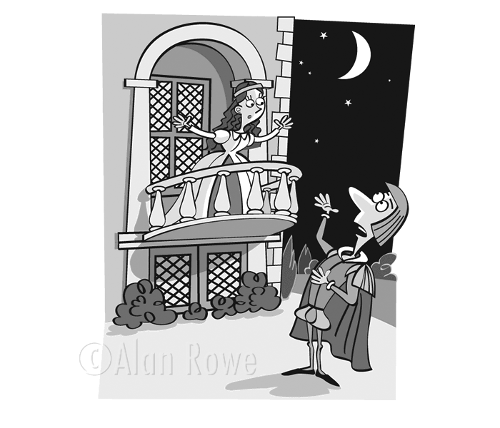
Name Romeo and Juliet by William Shakespeare
Act II Study Guide
Study Questions
1. How does Romeo wind up in Juliet’s orchard?
2. Who keeps interrupting the balcony scene?
3. What do Romeo and Juliet plan to do the next day?
4. What is Friar Laurence’s special skill or area of knowledge?
5. Why does the Friar agree to marry Romeo and Juliet?
6. Who has sent Romeo a letter that challenges him to a duel?
7. How does the Nurse react when she finally returns?
8. How does the Nurse feel about the marriage?
9. The Friar warns Romeo again about something. What is it?
10. How many people know of the marriage?
Important Quotes—Interpret in Plainspeak.
11. “O Romeo, Romeo! Wherefore art thou Romeo? _____________________________________________
Deny thy father and refuse thy name! _____________________________________________
Or, if thou wilt not, be but sworn my love, _____________________________________________
And I’ll no longer be Capulet.” _____________________________________________
12. “Then plainly know my heart’s dear love is set __________________________________________________
On the fair daughter of rich Capulet;” __________________________________________________

13. “…but first let me tell ye, if ye should lead her in a fool’s paradise, as they say, it were a very gross kind of behavior….”

______________________________________________________________________

______________________________________________________________________

______________________________________________________________________

______________________________________________________________________

14. “These violent delights have violent ends ______________________________________________________________________
And , in their triumph die, like fire and powder, ______________________________________________________________________
Which, as they kiss, consume.”
______________________________________________________________________

Who is Speaking? To Whom?
15. __________________ “With love’s light wings did I o’erperch these wall, ________
For stony limits cannot hold love out.”
16. _________________ “This bud of love, by summer’s ripening breath ________
May prove a beauteous flower when next we meet.”

Label the following as PERSONIFICATION, METAPHOR, SIMILE, or ALLITERATION.
17. ___________________________The gray-eyed morn smiles on the frowning night.”
18. ___________________________“It is the east, and Juliet is the sun.”
19. __________________________ “My ears have not yet drunk a hundred words
Of thy tongue’s uttering, yet I know the sound.”
20. What is the difference between a monologue and a soliloquy? Give an example of each from either Act One or Two. Don’t quote but summarize and explain what makes it a monologue or a soliloquy.
______________________________________________________________________________
______________________________________________________________________________
____________________________________________________________________________________________________________________________________________________________

